**AI Enemy**

<https://www.youtube.com/watch?v=zNJEvAGiw7w&list=PL4G2bSPE_8ukuajpXPlAE47Yez7EAyKMu>

1. Create a Third person template project.
2. Create AI folder in Content Browser
3. Create a new character (Name it AI Enemy)
4. Open it add skeleton mesh (Mannequin)
5. Add Thirdperson Anim BP
6. Create a new AIController (From blueprint class)
7. Create Behaviour Tree and BlackBoard
8. Select AI controller in enemy character defaults
9. In AI Enemy character BeginPlay - add BP run behaviour tree
10. 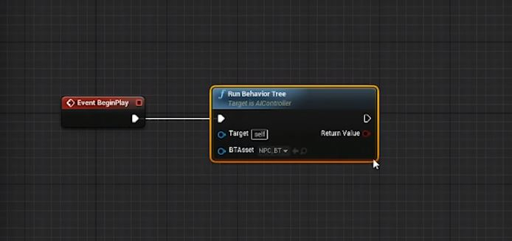
11. Select our behaviour tree in Run Behaviour Tree node.
12. Open Behaviour Tree (it is a decision making tree)
13. Drag from root and pick selector and then choose sequence. Add another sequence
    1. Selector selects and sequence play in sequence
    2. Explain execution numbers
14. Drag enemy into level.
15. Drag in nav mesh bound volume in to scene(scale and hit p to show)
16. In BlackBoard create a new key of type Vector and name it ActorLocation
17. Back to Behaviour tree.
18. Create new task by clicking on New Task button.
19. Create Execute event and finish execute
20. 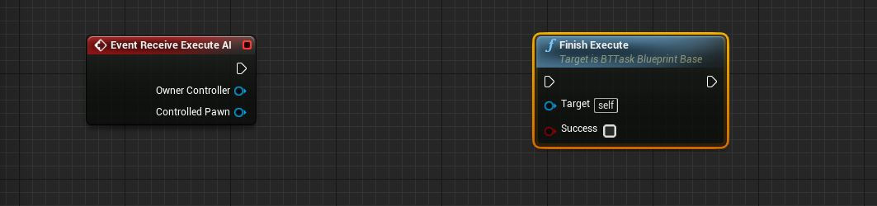
21. Create new variable of type BlackboardKeySelector, Name it Vector.
22. Set Variable to be public
23. Add following Blueprint
24. 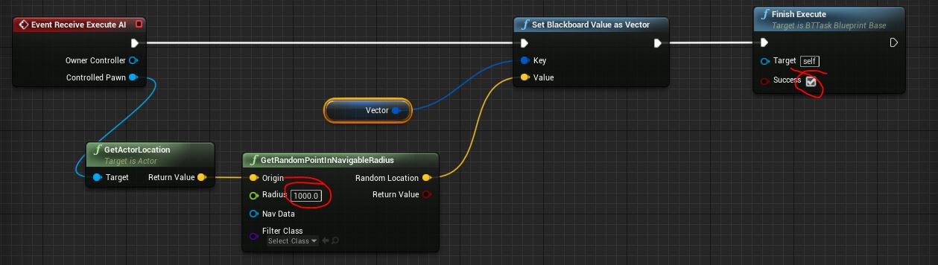
25. Rename the task to a logical name
26. Add the new task to Behaviour tree as follows
27. 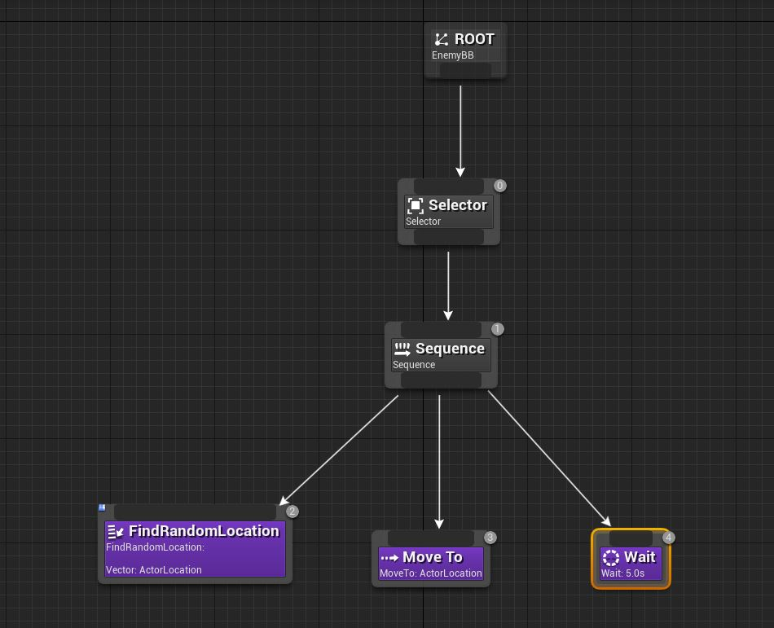
28. Compile and the character should run to Random locations in the level.
29. To avoid snap rotation of the character do the following
    1. In class defaults - Uncheck "Use Controller Rotation Yaw"
    2. In CharacterMovement - Check "Orient Rotation to Movement"
30. We can rename the Sequence to "Go to Random Location"